 | 10.1.16 Editors - Compositor Editor - Header - Add Menu - Vector
Table of content
Detailed table of content 1
Add menu - Vector 3
Combine XYZ 3
Separate XYZ 3
Normal 4
Vector Curves 4

Detailed table of content
Detailed table of content
Detailed table of content 1
Add menu - Vector 3
Combine XYZ 3
Input 3
X Y and Z 3
Output 3
Color 3
Separate XYZ 3
Input 3
Vector 3
Output 3
X, Y and Z 3
Mix Vector 4
Inputs 4
Factor 4
Value A 4
Value B 4
Properties 4
Data Type 4
Factor Mode 4
Clamp Factor 4
Outputs 4
Result 4
Vector Curves 5
Inputs 5
Vector 5
Properties 5
Channel 5
Channel buttons 5
Curve edit field 5
Selecting Points 5
Adding Points 5
Navigation elements 5
Zoom in and out 5
Tools 5
Reset View 5
Vector Handle 6
Auto Handle 6
Auto Clamped Handle 6
Extend horizontal 6
Extend extrapolated 6
Reset Curve 6
Use Clipping 6
Delete Points 6
Outputs 6
Vector 6
Vector Math 6
Inputs 6
Vector 6
Vector 6
Properties 7
Operation 7
Outputs 7
Value 7
Vector Rotate 7
Inputs 7
Vector 7
Center 8
Axis 8
Angle 8
Properties 8
Type 8
Invert 8
Outputs 8
Vector 8

Add menu - Vector
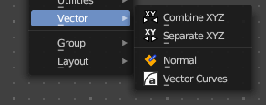
Here you find mainly nodes for vector data manipulation.

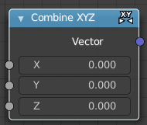
Combine XYZ
Same as with Combine RGB node. It combines color values. But instead combining rgb values, which are in the range of 0 to 255, it uses values in the range from 0 to 1.

Input

X Y and Z
X, Y and Z values.

Output

Color
Color output.

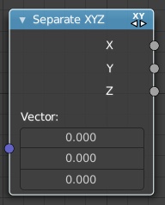
Separate XYZ
Same as with Separate RGB node. It separates color values. But instead separating rgb values, which are in the range of 0 to 255, it uses a vector with the values in the range from 0 to 1.

Input

Vector
The Input vector.

Output

X, Y and Z
The output vectors for X, Y and Z

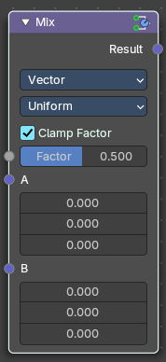
Mix Vector
The Mix Vector node blends two vector inputs using a specified factor. It’s useful for compositing tasks that involve motion vectors, directional effects, or spatial blending, offering precise control over how two sets of vector data are combined

Inputs

Factor
Controls the amount of influence the node exerts on the output result.

Value A
The back value.

Value B
The top value.

Properties

Data Type
Set to Vector, indicating the node mixes vector values.

Factor Mode
The method of mixing.
- Uniform: A single float controls the mix across all vector components.
- Non-Uniform: A vector input controls the mix per component (X, Y, Z).

Clamp Factor
Limit the highest color value to not exceed 1.

Outputs

Result
Vector output.

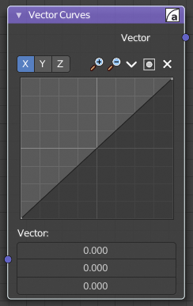
Vector Curves
The Vector Curves node maps an input vector components to a curve.

Inputs
In the shader context the node also has an additional Factor property.

Vector
Standard vector input.

Properties

Channel

Channel buttons
X, Y, Z. Clicking on one of the channels displays the curve for each.

Curve edit field
Create and tweak a Bezier curve that varies the input levels (X axis) to produce an output level (Y axis).


Selecting Points
You can select curve points. This reveals two edit boxes for the x and y coordinate of this point.
Selected points can be moved around. Left click at them, hold the mouse button down and move them to a new location.


Adding Points
You can add new curve points by simply left clicking at the curve. Move the mouse to position them where you need it.

Navigation elements
The navigation elements at the top are described from left to right.

Zoom in and out
The two buttons with the magnifying glass at it zooms in and out in the curve window.

Tools

Tools is a menu where you can find some curve related tools.

Reset View
Resets the curve windows zoom.

Vector Handle
Set handle type to Vector.

Auto Handle
Set handle type to Auto.

Auto Clamped Handle
Set handle type to Auto Clamped.

Extend horizontal
Extends the curve before the first curve point and behind the last curve point horizontally.

Extend extrapolated
Extends the curve before the first curve point and behind the last curve point extrapolated.

Reset Curve
Resets the curve to the initial shape.


Use Clipping
Clipping options. Set up clipping for the stroke.

Delete Points
Deletes selected curve points.

Outputs

Vector
Standard vector output.

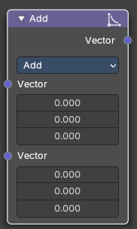

Vector Math
The Vector Math Node performs math operations.

Inputs

Vector
First numerical value. The trigonometric functions accept values in radians.

Vector
Second numerical value. This value is not used in functions that accept only one parameter like the trigonometric functions, Round and Absolute.

Properties

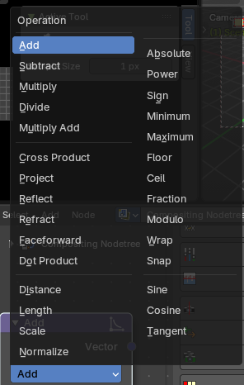
Operation
Here you can choose what mathematical operation to perform.

Outputs

Value
Numerical value output.

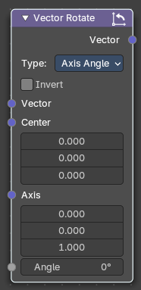

Vector Rotate
The Vector Rotate node rotates a vector around a specified axis and center point. It’s useful for compositing tasks involving directional transformations, such as rotating motion vectors, normals, or custom vector fields

Inputs

Vector
The input vector to be rotated.

Center
The pivot point around which the vector is rotated.

Axis
The axis of rotation, defined as am XYZ based 3D vector

Angle
The amount of rotation in degrees.

Properties

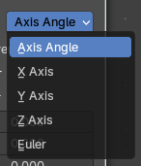
Type
Determines the rotation method.
- Axis Angle: Rotates around a custom axis by a specified angle.
- X/Y/Z Axis: Rotates the vector around the X/Y/Z-axis.
- Euler: Applies rotation using Euler angles in XYZ order.

Invert
When enabled, reverses the direction of the rotation.

Outputs

Vector
The rotated vector result.

